Robot Shop User Manual

To first execute the program, you will need to enter ”make” in the command line and that will compile all of the files we need for the program

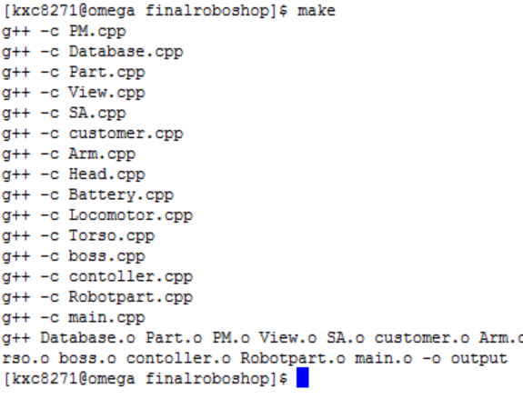

Once all of the files have compiled, you need to execute the program by entering “./output”. That command will take you to the main menu.

When you first execute the program, you will enter a Command Line interface that will prompt you with 5 specific choices.

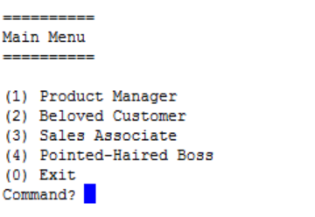

The first choice is to go to the “product manager”. The Product Manager oversees all the specific parts that get created.

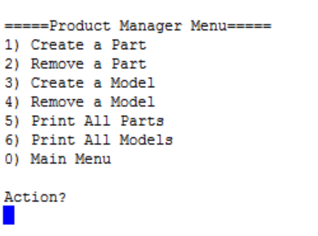

The program is currently not precompiled with parts but we have made an “Easter egg” to make your life easier. If you press the letter ”8”, it will create plenty of each kind of part so you can start creating models. The menu above will allow you to create parts and models and display the ones they currently have.

1. - Will allow you to create a part from scratch and specify what type it is.
2. - Will remove any parts that have been created
3. - Will Create a model if there is parts already created for all types
4. - Will remove any model that has been created
5. - Prints all created parts
6. - Prints all created models
7. - Takes you back to the previous menu

If you are back at the main menu and you press “2”, you will enter the customer menu:

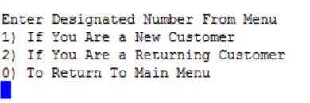

If you choose option 1 or 2 it will take to the next menu to make an action:

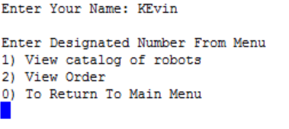

This menu will allow you to view the catalog of robots that are ready to be sold and will show their prices

If you choose ”3” in the main menu it will take you to the sales associate

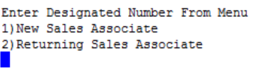

Login to your account and then it will take you to the login screen below

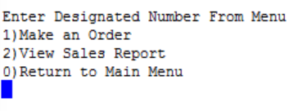

This screen will allow you to make an order for a customer and view all previous sales

If you enter ”4” in the main menu it will take you to the boss’s menu

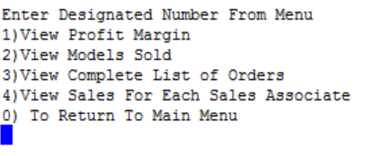

IF you enter ”1” in the boss menu, it will take you to how much profit we make for each Model type that is sold

If you enter “2”, it will show the number of models that have been sold

If you enter “3”, it will show the all orders that have been made

If you enter “4”, it will show which sales associate have made the most sales

“0” will take you back to the main menu